**Extended Abstract Headline**

(Times New Roman, 14 Font Size, Capital Each Word, Centred)

\***Author’s Name and Surname¹, Author’s Name and Surname ², Author’s Name and Surname ³, Author’s Name and Surname 4, Author’s Name and Surname 5**

1(Byline First Author)

2(Byline Second Author)

3(Byline Third Author)

4(Byline Fourth Author)

5(Byline Fifth Author)

*Corresponding author’s email* : [xxxxx@yyyy.zzzz.mm](mailto:xxxxx@yyyy.zzzz.mm)

**Abstract**

Abstract should be written in 200 words and less than 300 words , Times New Roman with font size 11 font size, justified alignment, and single line spacing. This section summarized an **overview of the goal, method, finding,discussion and future recommendations**

**Keywords:** Keywords that correspond to the work are stated in this section. The keywords are at least three and semi-colon is used to seperate them.

**1) Introduction [Main Heading, 12 pt Font, Bold, Font Style: Times New Roman]**

The extended abstracts should be written in a shorter format than the complete text and adhering to the structured abstract's underlying structure.

The components of the extended abstract that comprise the subtitles are the **abstract and keywords, the introduction and objective, the method, the findings and analysis, the discussion and recommendations, and the conclusion**.

**FORMAT:**

* The extended abstract for the entire work must be written in **Times New Roman** font with **size 11** and **single line spacing**.
* Figures, tables, formulae, and pictures may be included in extended abstracts.
* The **figures and tables** caption is centred, bold, and in Times New Roman 11 pt. It is located **below the figure** and **above the table**. English numerals must be used to number all the figures & tables accordingly.
* A4 paper sizes are used to produce page margins, which are 2.5 cm wide on the right, left, top, and bottom.
* The lines' ends ought to be aligned to the right, and there should not be any syllable division.
* The introductory part should clearly highlight the contrasts between the mentioned work and earlier, comparable efforts, as well as an examination of the current literature on the issue.
* The extended abstracts should include references and be no fewer than 3 pages, with a maximum of 8 pages. The pages should not be numbered.

[The extended abstracts **OUGHT TO FOLLOW THE FORMAT** that clarifies the declaration's substance and, therefore, the work's preparation stage]

**2) Materials and Resources**

All sources and materials used in the work must be properly mentioned.

**3) Methods**

All methods applied in the work needs to be properly explained.

**4) Finding AND Analysis**

**4.1) Subtitle**

* Every table, picture, and figure need to be centred.
* Figures and images should be numbered together with figure descriptions provided beneath the figure or image. [ex; Figure 1]
* The tables should also be numbered with the table header placed at the top of the chart. [ex; Table 1]
* The headers for tables, images, and figures should be centred, written in uppercase beginning characters, and bold.
* The author's last name and the publication date should appear immediately beneath any references (if any) for the tables, figures, and pictures.

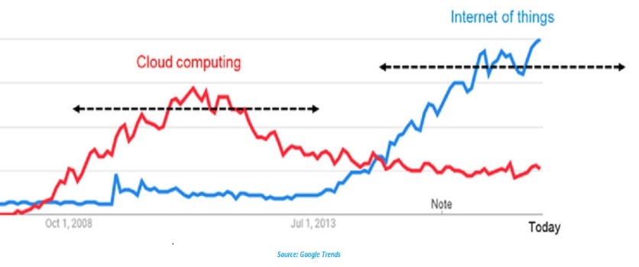

**Figure 1.** Figure Header

**Table 1.** Descriptive Statistics of Tech Platform

|  |  |  |
| --- | --- | --- |
| **Tech Platform** | **Cloud Computing** | **Internet of Things** |
| 1 | Increase | Static |
| 2 | Decrease | Increase |

*Reference: author surname and publication date*

**5) Discussions AND Recommendations**

All discussion problems and recommendations of of the work need to be stated with clear explanation. Provide strong evidence for the explanation stated.

Please follow the instruction in [4.2) Subtitle] **(if)** you want to insert the images, figure or tables as the evidence.

**6) Conclusion**

Include the following in your conclusion: (1) the abstractions and concepts deduced from the findings; (2) any deviations from or issues with these concepts; (3) the work's theoretical and/or practical consequences; and (5) conclusions and suggestions.

**Acknowledgement**

Acknowledge your research grant, organization, scholarship (where relevant).

**References**

* **Total no. of references must not exceed 30**.
* **List**according to **APA styles** along with DOIs of reference articles.
* Reference list must be **alphabetized by the last names of the first author of each work.**Authors' names are inverted (last name first); DO NOT write out the author/s first and middle name, use an initial only.
* Use hanging function by 1 cm for the next line. For Example:

Getting started. (n.d.). Retrieved September, 5, 2024,

from <http://final-year-projects.com/References.htm>.

Hassan, O. S. & Alavi, R. (2024). *Guidelines for CMBA research paper*. Sarawak:

UNIMAS.

Hubbuch, S. M. (2024). *Writing research paper across the curriculum* (3rd ed.). Florida: Hartcourt

Brace Jovanovich.

Mauch, J. E. & Birch, J. W. (2024). *Guide to the successful thesis and dissertation*. New York:

Marcel Dekker.

Rudestam, K. E. & Newton, R. R. (2024). *Surviving your dissertation*. California:

SAGE Publications.

Tuckman, B. W (2024). *Conducting educational research* (3rd ed.). Florida:

Harcourt Brace Jovanovich.

Faculty of Industrial Management. (2024). *Thesis Guideline for Report Writing.* UNISEL.

Writing report. (n.d.). Retrieved February, 2, 2024,

from <http://.cnjc-bsa.org/eagle/report.html>.