Extended Abstract Headline
(Times New Roman, 14 Font Size, Capital Each Word, Centred)

*Author’s Name and Surname¹, Author’s Name and Surname ², Author’s Name and Surname ³, Author’s Name and Surname ⁴, Author’s Name and Surname ⁵

¹(Byline First Author)

²(Byline Second Author)

³(Byline Third Author)

⁴(Byline Fourth Author)

⁵(Byline Fifth Author)

*Corresponding author’s email* : xxxxx@yyyy.zzzz.mm

Abstract

Abstract should be written in 200 words and less than 300 words , Times New Roman with font size 11 font size, justified alignment, and single line spacing. This section summarized an overview of the goal, method, finding,discussion and future recommendations

Keywords: Keywords that correspond to the work are stated in this section. The keywords are at least three and semi-colon is used to seperate them.

1) Introduction [Main Heading, 12 pt Font, Bold, Font Style: Times New Roman]

The extended abstracts should be written in a shorter format than the complete text and adhering to the structured abstract's underlying structure.

The components of the extended abstract that comprise the subtitles are the abstract and keywords, the introduction and objective, the method, the findings and analysis, the discussion and recommendations, and the conclusion.

FORMAT:

- The extended abstract for the entire work must be written in Times New Roman font with size 11 and single line spacing.

- Figures, tables, formulae, and pictures may be included in extended abstracts.

- The figures and tables caption is centred, bold, and in Times New Roman 11 pt. It is located below the figure and above the table. English numerals must be used to number all the figures & tables accordingly.

- A4 paper sizes are used to produce page margins, which are 2.5 cm wide on the right, left, top, and bottom.

- The lines' ends ought to be aligned to the right, and there should not be any syllable division.

- The introductory part should clearly highlight the contrasts between the mentioned work and earlier, comparable efforts, as well as an examination of the current literature on the issue.

- The extended abstracts should include references and be no fewer than 3 pages, with a maximum of 8 pages. The pages should not be numbered.

[The extended abstracts OUGHT TO FOLLOW THE FORMAT that clarifies the declaration's substance and, therefore, the work's preparation stage]

2) Materials and Resources

All sources and materials used in the work must be properly mentioned.

3) Methods

All methods applied in the work needs to be properly explained.

4) Finding AND Analysis

4.1) Subtitle

- Every table, picture, and figure need to be centred.

- Figures and images should be numbered together with figure descriptions provided beneath the figure or image. [ex; Figure 1]

- The tables should also be numbered with the table header placed at the top of the chart. [ex; Table 1]

- The headers for tables, images, and figures should be centred, written in uppercase beginning characters, and bold.

- The author's last name and the publication date should appear immediately beneath any references (if any) for the tables, figures, and pictures.
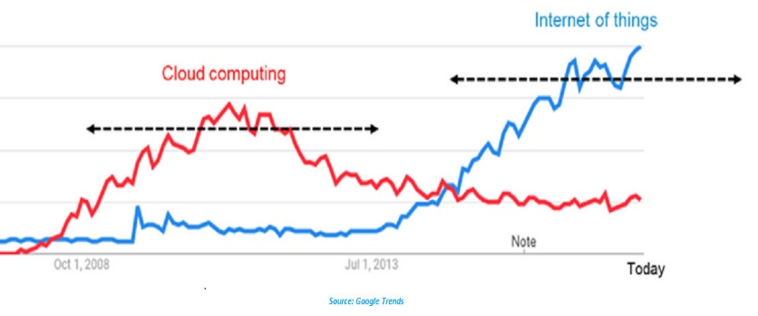
Figure 1. Figure Header

Table 1. Descriptive Statistics of Tech Platform
Tech Platform | Cloud Computing | Internet of Things
1 | Increase | Static
2 | Decrease | Increase
Reference: author surname and publication date

5) Discussions AND Recommendations

All discussion problems and recommendations of of the work need to be stated with clear explanation. Provide strong evidence for the explanation stated.

Please follow the instruction in [4.2) Subtitle] (if) you want to insert the images, figure or tables as the evidence.

6) Conclusion

Include the following in your conclusion: (1) the abstractions and concepts deduced from the findings; (2) any deviations from or issues with these concepts; (3) the work's theoretical and/or practical consequences; and (5) conclusions and suggestions.

Acknowledgement

Acknowledge your research grant, organization, scholarship (where relevant).

References
- Total no. of references must not exceed 30.

- List according to APA styles along with DOIs of reference articles.

- Reference list must be alphabetized by the last names of the first author of each work. Authors' names are inverted (last name first); DO NOT write out the author/s first and middle name, use an initial only.

- Use hanging function by 1 cm for the next line. For Example:

Getting started. (n.d.). Retrieved September, 5, 2024,
from http://final-year-projects.com/References.htm.

Hassan, O. S. & Alavi, R. (2024). Guidelines for CMBA research paper. Sarawak:
UNIMAS.

Hubbuch, S. M. (2024). Writing research paper across the curriculum (3rd ed.). Florida: Hartcourt
Brace Jovanovich.

Mauch, J. E. & Birch, J. W. (2024). Guide to the successful thesis and dissertation. New York:
Marcel Dekker.

Rudestam, K. E. & Newton, R. R. (2024). Surviving your dissertation. California:
SAGE Publications.

Tuckman, B. W (2024). Conducting educational research (3rd ed.). Florida:
Harcourt Brace Jovanovich.

Faculty of Industrial Management. (2024). Thesis Guideline for Report Writing. UNISEL.

Writing report. (n.d.). Retrieved February, 2, 2024,
from http://.cnjc-bsa.org/eagle/report.html.

